A Novel Approach to Secure Big Data Processing in the Cloud

Tatiana Galibus
Viktor Krasnoproshin
Belarusian State University
220030 Minsk, 4, Nezavisimosti
Minsk – Belarus.
+375 017 226-59-40
{tan2tan@gmail.com, krasnoproshin}@bsu.by

Rubem Pereira
Paul Fergus
Liverpool John Moores University
LJMU City Campus, Liverpool, England
+44 0151 231 2103
{p.fergus, r.pereira}@ljmu.ac.uk
Edison Pignaton de Freitas
Julio C.S. dos Anjos
Cláudio Resin Geyer
Federal University of Rio Grande do Sul
UFRGS – INF – CP: 15064
91501-970 Porto Alegre - RS - Brazil
+55 51 3308 6168
{jcsanjos, edison.pignaton, geyer}@inf.ufrgs.br

Anton Zaleski
H.E.R.M. Vissia
Byelex Multimedia Products BV Argon 1, 4751 XC Oud Gastel, The Netherlands
{a.zalesky@by.byelex.com, h.vissia@byelex.com}
Rafael Timóteo de Sousa Júnior
João Paulo C. L. Costa
University of Brasilia
UnB - FT – ENE – CP: 4386
70910-900, Brasília - DF - Brazil
+ 55 61 3107-5580
joaopaulo.dacosta@ene.unb.br, desousa@unb.br

Volker Markl
Technische Universität Berlin
DIMA - School of EECS (IV)
Einsteinufer 17
10587 Berlin - Germany
+49 30 314 23555
volker.markl@TU-Berlin.de

ABSTRACT
Security is an important concern in networked computer systems, which is especially remarkable when the system has to handle large amounts of data and a number of different users may access this data with different accessing grants. Observing this demand, this work proposes an innovative approach to provide a security infrastructure to support Big Data Analysis in Cloud-based systems. This approach considers systems in which large volumes of data from heterogeneous sources are handled and in which users may access the system by different platforms, consuming or providing data. The proposed security infrastructure provides users’ authentication and data access control mechanisms tailored to the high demanding cloud-based big data environment. Preliminary results show the adequacy of the proposed security infrastructure to the aimed cloud-based system.
CCS Concepts
•Computer systems organization ➝Distributed architectures ➝Cloud computing •Networks ➝Network services ➝Cloud computing •Networks ➝Network properties ➝Network security.
Keywords
Cloud systems security, Big data security, Cloud-based Big Data processing.

INTRODUCTION
Technological advances are increasingly supporting human activities. In this context, an important aspect is that computer based systems can collect and store data about different human interests and follow its evolution almost on a continuous basis. Similarly, the environment (built and natural) is ever more monitored by sensing devices that sample some aspects of the environment and generate large volumes of data. Cloud computing is a promising technology to address the challenges of this new reality. It already became an essential part of the global IT reality as it has been used as a platform for business applications and data processing [1]. The current challenge is how to construct such efficient processing infrastructures to handle massive amounts of data, which is a great demand in the field of big data research and industry communities.
Due to fact that this approach has specific characteristics which distinguish it from other applications, such as, volume, variety, velocity and veracity [2] it demands new solutions to face the challenges posed by the context of its distinguished operation scenario. A large volume of data (volume) from different sources that ingress in the cloud with different formats and sources (variety) are processed in real-time (velocity) with high accuracy (veracity). However, data need to be homogenized and coherently handled by the cloud or other infrastructures, like hybrid infrastructures [3]. This infrastructure needs to be secured to guarantee the data privacy and avoid misusage of the services it offers.

Permission to make digital or hard copies of all or part of this work for personal or classroom use is granted without fee provided that copies are not made or distributed for profit or commercial advantage and that copies bear this notice and the full citation on the first page. To copy otherwise, or republish, to post on servers or to redistribute to lists, requires prior specific permission and/or a fee.

SAC’16, April 4-8, 2016, Pisa, Italy.
Copyright 2016 ACM 978-1-4503-3739-7/16/04…$15.00.
http://dx.doi.org/xx.xxxx/xxxxxxx.xxxxxxx

The key vulnerabilities of such infrastructures are the constantly increasing openness and scalability. The proposed solutions are focused mainly on achieving the basic big data processing characteristics. The security requirements for such systems are not taken into account and the solutions are not analyzed from the point of security. Therefore, the general modeling of the big data security architecture as well as the implementation design of verifiable big data security infrastructure is key problems in the nearest future of the big data processing systems. The importance of security increases rapidly with the growth of BD industry.
The efficient BD security infrastructure should include the following components:
1. Authentication services;
2. Access control infrastructure for the supported access policies;
3. Encryption protocols and other standard cryptographic services;
4. Fast on-the-fly auditing services.
Currently, there are several industrial approaches to securing the BD infrastructures on the market: Cloudera Sentry, IBM InfoSphere Optim Data Masking, Intel's secure Hadoop distribution, DataStax Enterprise, DataGuise for Hadoop, Protegrity Big Data Protector for Hadoop, Revelytix Loom,Zettaset Secure Data Warehouse, Apache Accumulo, Knox Gateway (contributed by HortonWorks) and Project Rhino (contributed by Intel). All mentioned approaches are designed for the Hadoop infrastructure and utilize Kerberos secure resource sharing protocol. In the theoretical field it is possible to mention some works related to the concept of access control policy [13], hybrid environment machine-learning systems [16] among other, but there are no general analytical articles related to BD security. The existing approaches to securing the BD processing systems are designed and implemented as patches i.e. adjusted to the current needs of the system. The BD security theory lacks the formal conceptual models of the consistently secure BD processing systems, which obviously leads to the absence of the verifiable solutions for security [11], [14]. In other words, there is an obvious lack of analysis and theoretical research in this field while there is a great demand for the development general standardized strategy of protecting the big data processing systems.
The top 10 security problems in the big data cloud processing are mentioned in the CSA (Cloud security alliance) paper [15]. This work presents a proposal to address one of the most demanding of these problems, i.e. the problem of access control and which is related to the user privacy protection. The proposal presents a novel approach to the BD access control implementation. Our methodology is based on the specific access control methods designed for the big data processing incorporated into the cloud infrastructure The proposal includes a framework called Small & Medium-sized Enterprise Data Analytic in Real Time (SMART) and related access control methods that support and protect the data analytics processes and associated access policy. SMART is a modular framework for Big Data analysis that takes advantage of cloud, multiple clouds or hybrid infrastructures to provide support for Small & Medium-sized services operation. The core access control framework has already been successfully implemented in the protected cloud infrastructure.
The complete solution provides a secure and flexible cloud-based BD processing system capable to support the different types of services that can be securely combined to address specific needs of different application domains with different level of user access. The rest of this paper is structured as follows. Section 2 examines the works that are related with this proposal. In Section 3, there is an overview description of the main characteristics of the proposed cloud infrastructure. Section 4 describes the proposed authentication and access control mechanisms for this cloud infrastructure. Section 5 presents preliminary results for these proposed security mechanisms. Section 6 concludes the paper and presents suggestions for future.

RELATED WORKS
The big data approach is related to the distributed processing systems and currently, there are several trends in the field of distributed systems security. The three most important ones are highlighted in the following:
1. The traditional solutions for securing the computer-networked systems are based on the firewalls and network perimeter security. The problems tackled by this approach are not applicable for the cloud infrastructure. . The main tool for securing cloud-based systems is cryptography due to the fact that cloud systems do not have a centralized server and network perimeter [10], [14].
2. Hadoop security based on the Kerberos resource sharing protocol [17]. Kerberos a well-known and stable solution for the partially distributed systems where there is a trusted authority but it has its limitations in the cloud, the first of all, the necessity to synchronize the time zones of different users of the cloud is difficult and can lead to errors. Secondly, it is difficult and rather time-consuming to set up and configure the Kerberos infrastructure. It is preferable to use either public-key or attribute-based encryption for protecting the user privacy in the cloud system while the symmetric encryption should be used to support the fast processing of the bulk data.
3. Access control policies: The most well-known data encryption method supporting the access control policies is Attribute-based Encryption (ABE) [8], [9], [12]. Unfortunately, in practice, its general implementation meets some difficulties and limitations. In the light of these problems, our work addresses the limitations of the ABE approach and proposes the modified light-weighted ABE algorithm and corresponding cryptographic infrastructure specifically designed to be used on the cloud platform.
As it is possible to notice, none of the mentioned works operates the general conceptual models or implementation designs for the BD security infrastructures. Therefore, this paper proposes such security infrastructure in the form of the abstract model and implements this model for the specific cloud-based system. The abstract modelling is an important part of the security design architecture as it allows approaching the security problems more precisely and developing a better practical solution to solve them.

THE CLOUD INFRASTRUCTURE

Architecture Overview
Different cloud infrastructures have their own configuration parameters, and the availability and performance of offered resources can change dynamically according to several factors, including the degree of over-commitment that a provider employs. In this context, solutions are needed for the automatic configuration of complex cloud services at several abstraction levels. Cloud infrastructures comprising heterogeneous hardware environments may need the specification of configuration parameters at several levels such as the operational system, service containers and network capabilities [4]. As users need to execute applications may not know how to map their requirements to available resources, this lack of knowledge about the cloud provider infrastructure will lead either to overestimation or underestimation; both are equally bad as the former leads to waste of resources whereas the second sacrifices quality of service.
The application profile is optimized for all file sizes in the available infrastructure. As the systems are independent different data sizes can be manipulated at same time. Previous work has been performed on map-reduce for hybrid environments [3], [5]. Figure 1 illustrates the solution proposed to model a hybrid system which depicts a Global Dispatcher and Global Aggregator to be used on the infrastructure. The Global Dispatcher located outside the cloud has middleware functions for handling task assignment, and management of user-provided data. It is a centralized data storage system that manages policies for split data and distribution in accordance with the needs of each system. The working principle is similar to a publish/subscribe service in which the system obtains data and publishes computing results [3]. The Global Aggregator data output from both systems and merges them in order to obtain the final data set.

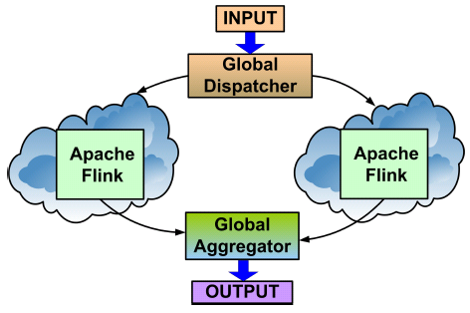
Figure 1: SMART Architecture

Internal Infrastructure Components
Hybrid infrastructure, where there are many cloud providers with heterogeneous environments and configurations, often needs to use an orchestrator to manage the results and data input from users. The orchestrator must be decentralized in order to improve data distribution in the network. The infrastructure enables the use of highly heterogeneous machines. When considering the use of a public cloud to extend the capacity of a community cloud, or desktop grid, several scenarios and data strategies are possible. The extent to which a set of data-distribution strategies is applicable to a given scenario depends on how much bandwidth is available. Two distinct Distributed File System (DFS) implementations may be required to handle data distribution in two scenarios, namely low-bandwidth and high-bandwidth.
The Apache Flink, formerly known as Stratosphere, [6] is the base infrastructure of the SMART framework system, represented in Figure 2. Its flexible pipeline enables several map-reduce and extended functions like Map, MapPartion, Reduce, Aggregate, Join and Iterative. It can be used in order to allow this cloud extension. The setting will be transparent to users because a middleware in a top level abstracts the complexity away from the users.
The different layers of the stack build on top of each other and raise the abstraction level of the program representations they accept:
• The API layer implements multiple APIs that create operator DAGs for their programs. Each API needs to provide utilities (serializers, comparators) that describe the interaction between its data types and the runtime. All programming APIs are translated to an intermediate program representation that is compiled and optimized via a cost-based optimizer.
• The Flink Common API and Optimizer layer takes programs in the form of operator DAGs. The operators are specific (e.g., Map, Join, Filter, Reduce, FlatMap, MapPartition, ReduceGroup, Aggregate, Union, Cross, etc) and the data is in nonuniform type. The concrete types and their interaction with the runtime are specified by the higher layers.
• The Flink Runtime layer receives a program in the form of a JobGraph. A JobGraph is a generic parallel data flow with arbitrary tasks that consume and produce data streams. The runtime is designed to perform very well both in setups with abundant memory and in setups where memory is scarce.
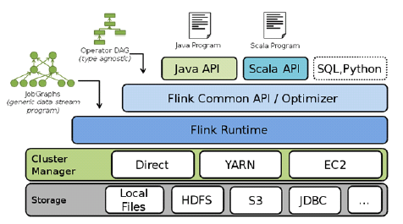
Figure 2: Apache Flink component stack
Flink explores the power of massively parallel computing for advanced analytics and leverages a novel, database inspired approach to analyze, aggregate, and query very large collections of either textual or (semi-)structured data on a virtualized, massively parallel cluster architecture. It combines the strengths of MapReduce/Hadoop with powerful programming abstractions in Java and Scala and a high performance runtime. In addition to basic data flow concepts as common in relational databases, or systems like Hadoop and Spark, Flink has native support for iterations, incremental iterations, and programs consisting of large DAGs (Directed Acyclic Graph) of operations. Particulary, it is possible to highlight the following:
• Flink uses a richer set of primitives than MapReduce, including primitives that allow the easy specification, automatic optimization, and efficient execution of joins. This makes the system a more attractive compilation platform for data warehousing, information extraction, information integration, and many other applications. The programmer does not need to worry about writing parallel code or hand-picking a join order.
• Flink includes native support rather than outside loop in Mahout [7] on top of Hadoop for iterative programs that make repeated passes over a data set updating a model until they converge to a solution. Flink contains explicit “iterate” operators including bulk iteration and delta iteration that enable very efficient loops over data sets, e.g., for machine learning and graph applications. These operators enable the specification, optimization, and execution of graph analytic and statistical applications inside the data processing engine.
• Different from Spark, Flink uses an execution engine that includes external memory query processing algorithms and natively supports arbitrarily long programs shaped as directed acyclic graphs. Flink offers both pipeline (inter-operator) and data (intra-operator) parallelism. Flink’s runtime is designed as a pipelined data processing engine rather than a batch processing engine, thus it supports both batch and streaming processing. Operators do not wait for their predecessors to finish in order starting processing data. This results in a very efficient handling of large data sets.

PROPOSED AUTHENTICATION AND ACCESS CONTROL MECHANISMS

Approach Overview
The proposed approach to secure Big Data systems on the cloud is an evolution of a cloud-based access control and privacy protection infrastructure which is currently implemented in protected enterprise cloud storage - Storgrid [18].
This infrastructure is the core of the protected environment in the cloud with the heterogeneous devices and attribute access policy. Therefore, it is suitable for the SMART cloud-based architecture and corresponding big data processing services.
The proposed security infrastructure includes the following components illustrated in Figure 3:
1) Encryption server. The encryption server manages all AC and encryption operations and grants the user access to the data storage. This server can store the encryption keys and/or connect to a separate Key Storage.
2) File storage. The file storage is secure in the sense that some of the files specified by the domain administrator are store, encrypted and have restricted access. Due to the fact that the file storage data is partially stored in the cloud i.e. externally it is recommended to encrypt this external part of file storage completely.
3) Client UI. The client can connect to the encryption server and ask for the permission to access the file storage in order to view/edit/upload specific files or folders.
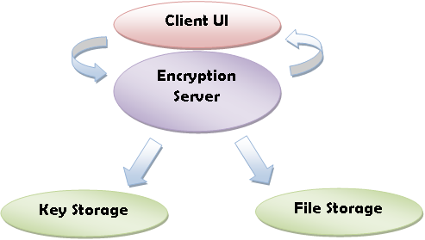
Figure 3: Components of the proposed security infrastructure and their interactions

Functionality
All components of the proposed system support the high-level cryptographic functions, including different types of encryption, timestamp verification and hashing. In order to increase efficiency, a hybrid encryption system is set up which is combined of both symmetric and attribute-based encryption. This configuration allows controlling the privacy of the users without compromising the overall encryption time. In addition, the basic ABE [8], [9] approach is modified in order to increase the speed of encryption and implemented the configuration parameters in order to set up the user key expiry dates and more sophisticated attribute sets corresponding both to the file shares and to the user groups. The detailed description of this modified ABE encryption is out of the scope of this paper.
The basic functionality of the security components are briefly described in the following:
1. File storage: The bulk data in the protected file storage is encrypted with the appropriate block cypher (AES, Blowfish, IDEA, Serpent). The key to the encrypted data is stored in the key storage and has expiry period in order to increase the protection. Once the portion of data is sent to the client, it is decrypted by the server and re-encrypted with another unique user session key.
2. Key storage: The symmetric keys for the data in the file storage are kept in the separate storage. The protection of the key storage is implemented via some strong authentication method i.e. two-factor authentication. Additionally, in order to increase the security of the sensitive data we propose the following methods:
• Set up the key expiry period;
• Use the separate keys for the separate files;
• Use the secret sharing mechanism in order to store the keys for the most important sensitive data.
3. Encryption server: The most important cryptographic services are run on the Encryption server. This server generates the user keys and connects to the client UI, i.e. a separate user of the system and decides whether the access to the specific dataset should be granted to this user. In addition, the server runs the key renewal routines, stores the user public keys and attributes besides the auditing data.
4. Client UI: The client UI connects to the encryption server and checks the expiry period of the user keys (in the case it has been configured) and permits the device user to view/edit/upload the data. Client UI stores the user keys for the ABE encryption and the unique symmetric session keys which serve for restricting the access to the downloaded files. The symmetric keys are encrypted with the ABE keys. The client allows the whole system to work in the heterogeneous environment as it supports different platforms and operating systems.
The described modular infrastructure allows setting up different components separately and configuring the security system according to specific needs. Also, as it will be further discussed, the integration of the security infrastructure into the Big Data environment is an easy task due to its flexibility and scalable architecture.
The main purpose of the proposed security infrastructure is the setup of the access control in the cloud-based protected environment. Access control mechanisms serve to run the following tasks:
• Authentication of users in the cloud system: The initial and the simplest authentication is performed by the user password and email id. In order to increase the security hierarchical system of authentication can be set up, i.e. for the highly sensitive data it is necessary to implement more sophisticated two-factor authentication when apart from the password and access to e-mail, the possession of a specific device is verified too. This can be used in the government services or services with the highly sensitive data.
• Provision of access control functions and protection of data from the unauthorized access: once the user is authenticated he/she can get access to the functions of the storage in order to upload or to download the data. The AC services are run by the encryption server. The server generates and distributes the user keys and keeps the group attributes along with the file sharing ids. Access control allows to securely distribute and show to the user (or accept from user) only the data he is permitted to view/edit. In order to achieve this protection, a special version of ABE is used with the implementation of both possible policies: key policy – KP, and cyphertext policy – CP, in order to support the attributes of the groups of users as well as the attributes of the file shares. This algorithm is developed specifically for the access structure of the proposed cloud architecture.
• Protection of of the user data privacy: Once the user wishes to access a separate file downloaded on user device the client uses his/her ABE key after performing the authentication in order to decrypt the symmetric session key and open the file.

Security Infrastructure of the SMART Cloud-Based Processing Service
In order to combine the SMART architecture and the proposed hybrid AC system it is necessary to separate the functions of the encryption server, i.e. the protection services that work once the data is uploaded (authentication, AC, encryption) which must run before the data is sent to the Global Aggregator, from the protection services that work when the data is downloaded, which must be set up after the data passes the Global Dispatcher (AC, decryption, key refreshment). The encrypted cloud storage is also separated. The whole ecosystem is shown in Figure 4.
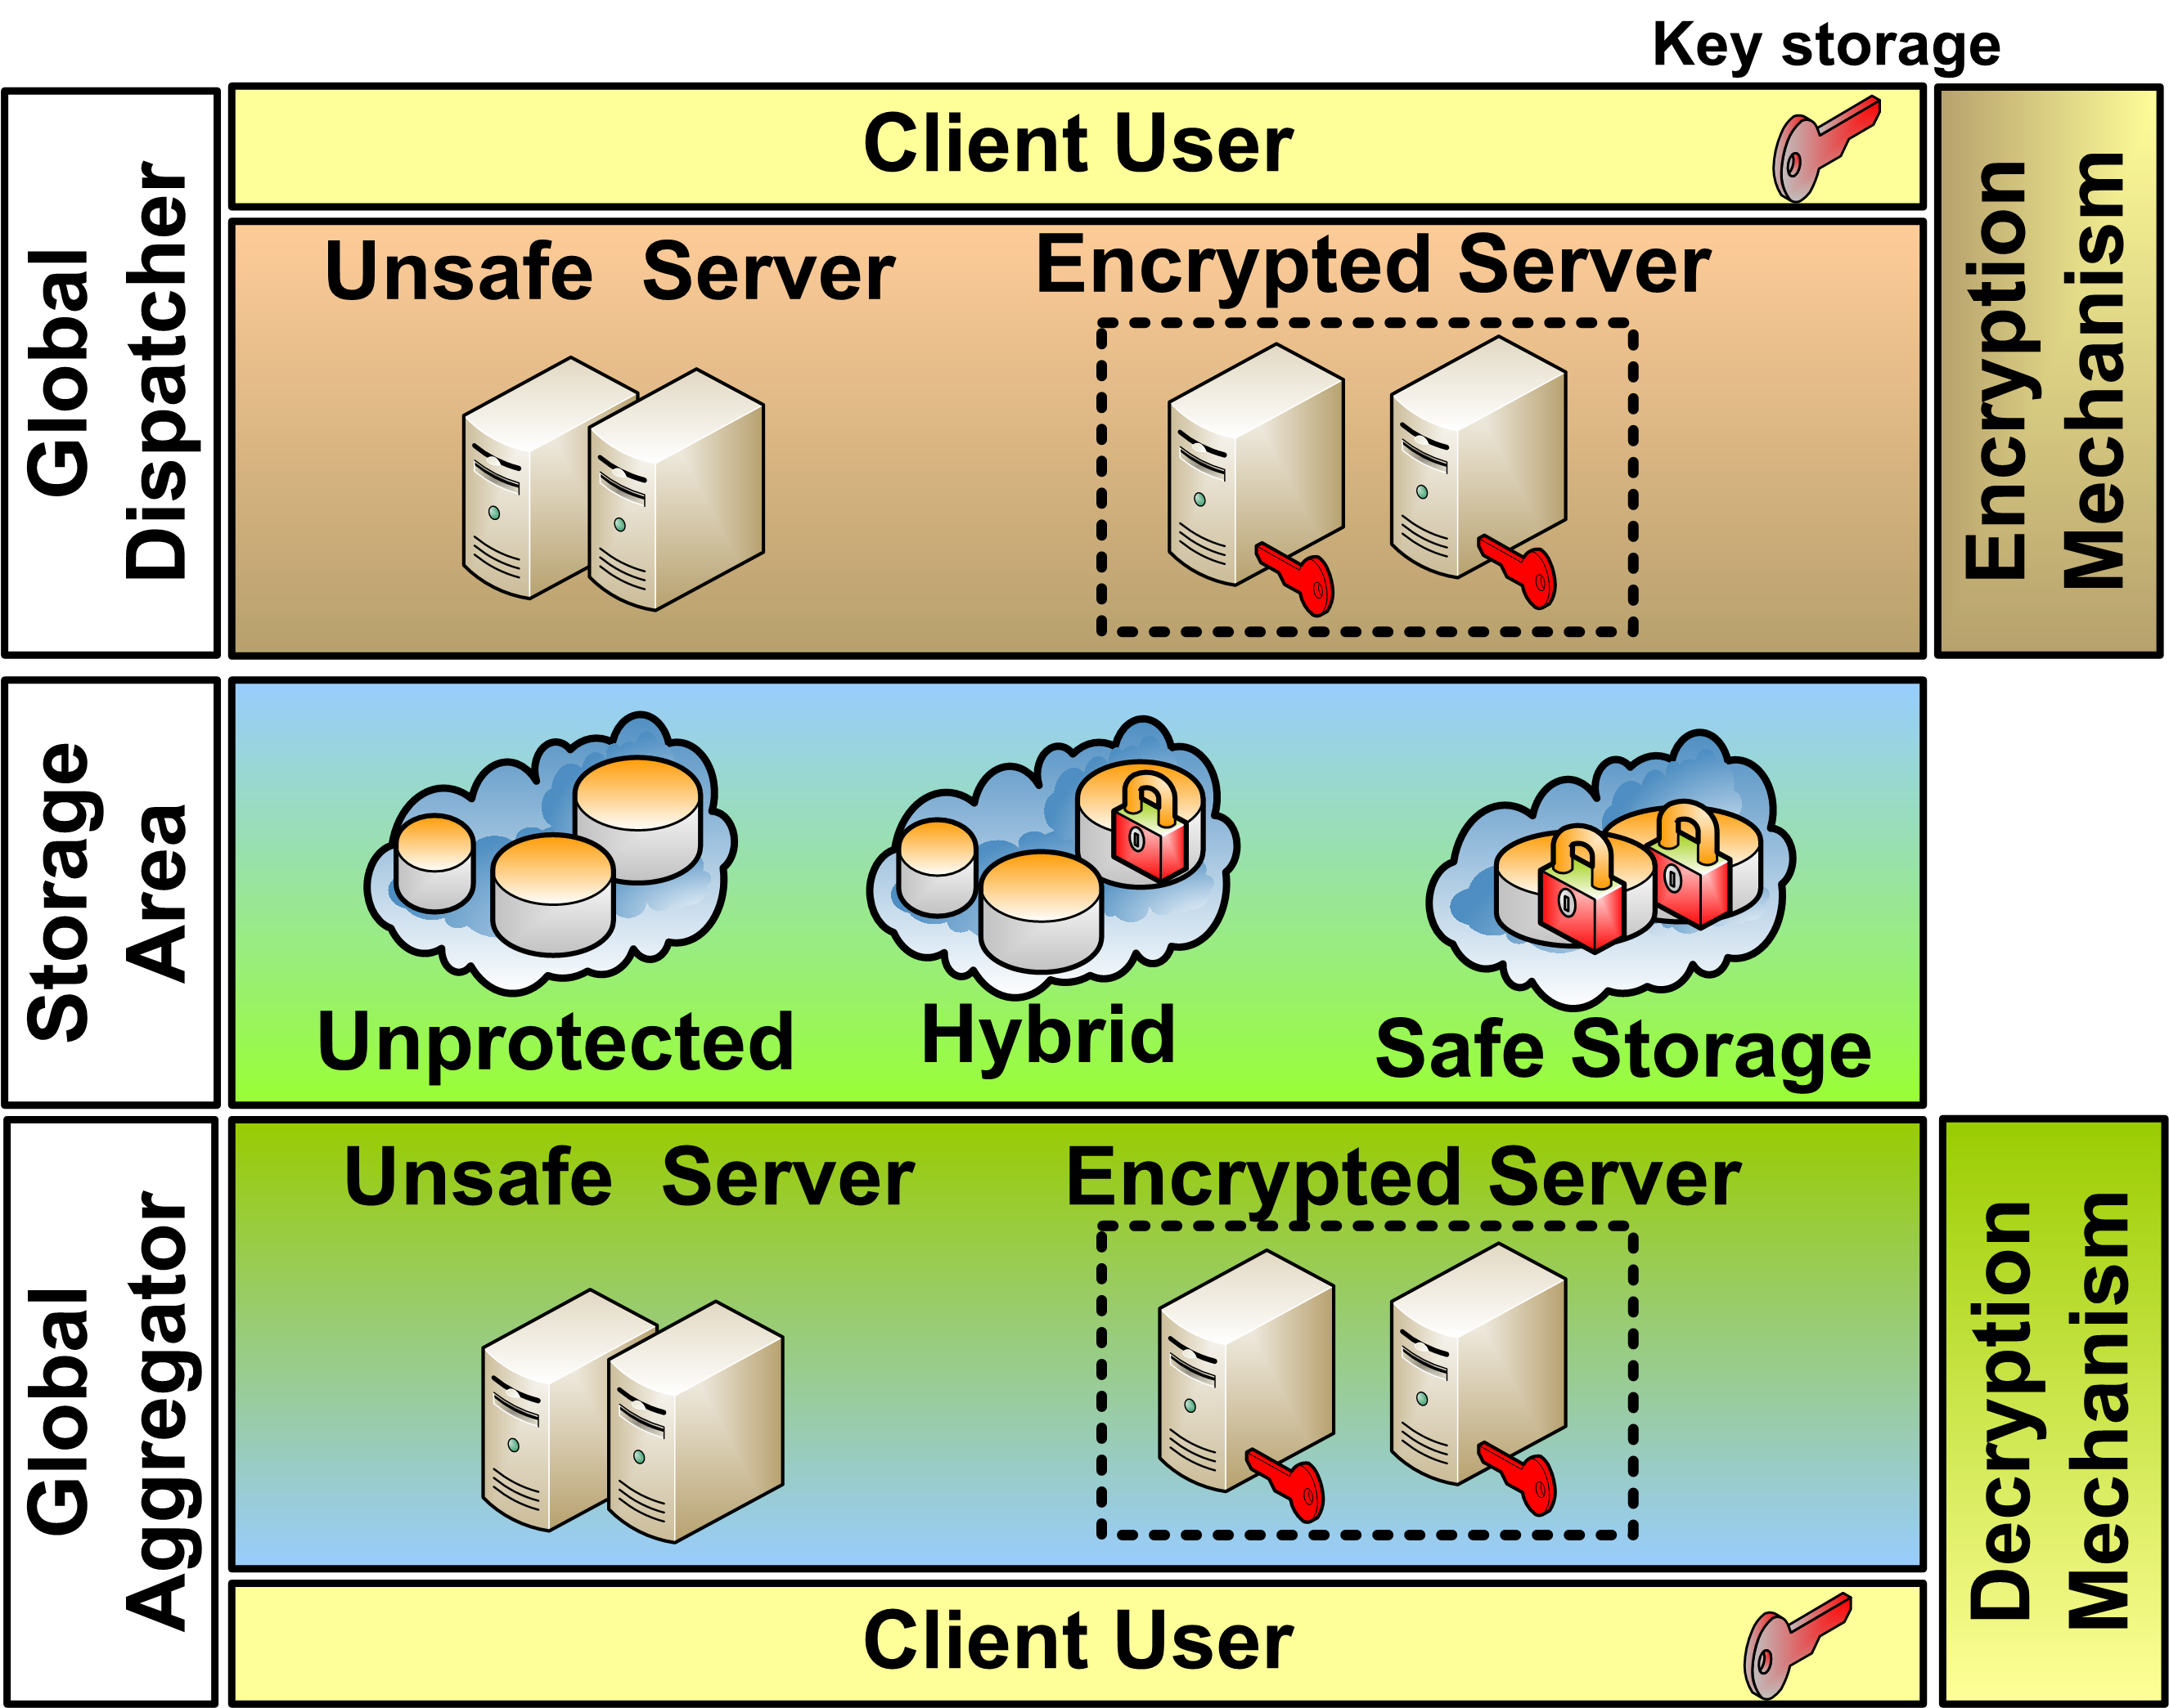
Figure 4: Security infrastructure integrated to the cloud environment
This integration model makes it possible to implement the required level of security and user privacy in all types of governmental and corporation organizations and services (like medical or governmental services) using the SMART infrastructure. The modular implementation design allows protecting the user privacy and control the access to the sensitive data in the heterogeneous environment via the Client UI developed for various OS and various platforms. The security is globally supervised with the help of the Encryption server and separate key storage. Additionally, this architecture can be easily extended in order to use more sophisticated methods of ensuring the data and key protection i.e. secret sharing or complex attribute policies.

IMPLEMENTATION AND PRELIMINARY RESULTS
The proposed security infrastructure is currently being implemented as part of the Storgrid project. Storgrid is a secure cloud storage management system which allows controlling the level of data security and user privacy for a particular organization. The basic security components i.e. server UI, client UI and protected file storage are currently in the testing phase. This section presents preliminary results from this testing phase. The work of the server is controlled by the administrator (or domain manager) who has the access to the server via his secret password and whose responsibility is to decide the level of security of the protected/public files with the help of the server web interface, which is shown in Figure 5.
The basic encryption method on the server side is 128 bit AES. This method is well-tested and provides a fast encryption of the big bulks of data. Additionally, the file storage secret key has expiry period so that the whole storage is re-encrypted on a daily basis which does not affect the performance of the system as this procedure is run in the night time. The preliminary results of the re-encryption testing taken from the server real-time log are show in Table 1.

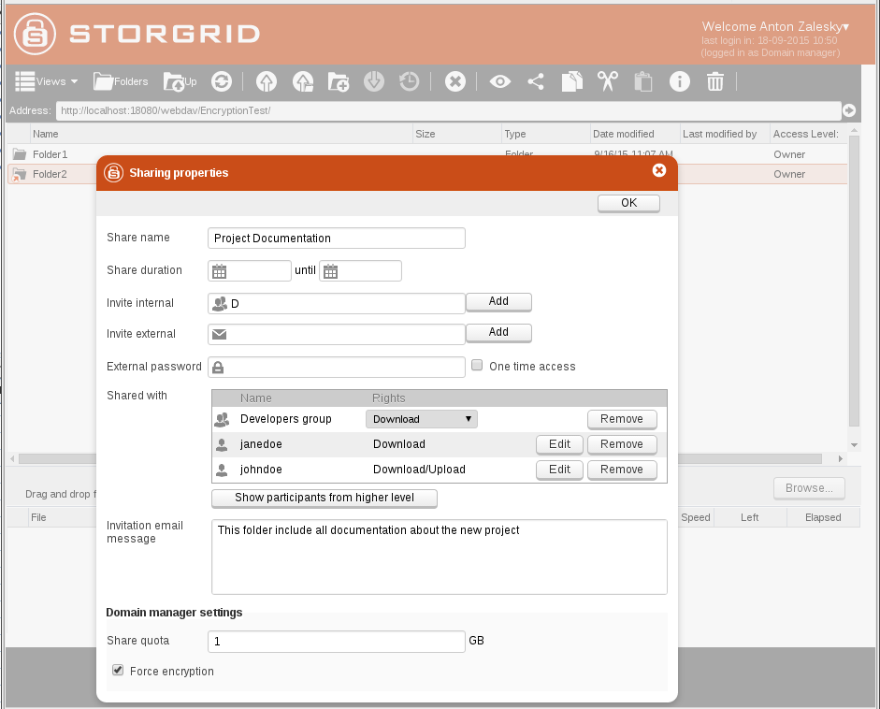
Figure 5: Storgrid web UI

Table 1: Re-encryption time results
Server Log | Encrypted Files Size (KB) | Duration (ms)
server.log_2015-09-18T18-06-28: refreshStorageEncryption for storage Storage[ id = 1003; encrypted = true;] | 16,304 | 324,345ms
server.log_2015-09-18T18-06-28: refreshStorageEncryption for storage Storage[ id = 1003; encrypted = true;] | 35,834. | 162,629ms
server.log_2015-09-18T18-07-23: refreshStorageEncryption for storage Storage[ id = 1003; encrypted = true;] | 21,501. | 124,399ms
server.log_2015-09-18T18-12-32: refreshStorageEncryption for storage Storage[ id = 1003; encrypted = true;] | 23,651. | 149,948ms
server.log_2015-09-18T18-40-00: refreshStorageEncryption for storage Storage[ id = 1003; encrypted = true;] | 28,614. | 523,232ms
server.log_2015-09-18T18-40-00: refreshStorageEncryption for storage Storage[ id = 1003; encrypted = true;] | 49,494. | 397,334ms
server.log_2015-09-18T18-55-02: refreshStorageEncryption for storage Storage[ id = 1003; encrypted = true;] | 41,751 | 533,838ms
server.log_2015-09-18T19-01-38: refreshStorageEncryption for storage Storage[ id = 1003; type = LOCAL_FILESYSTEM; encrypted = true;] | 45,360. | 368,900ms

The infrastructure allows integrating the existing corporate file infrastructure into the Storgrid and to build it from the scratch. Some files are not encrypted while others are encrypted and sent over the insecure network (in the cloud) encrypted. This concept allows to not overload the internal network and to control the security of the files. The control of this process is performed by the domain manager access control utility, which interface is shown in Figure 6.
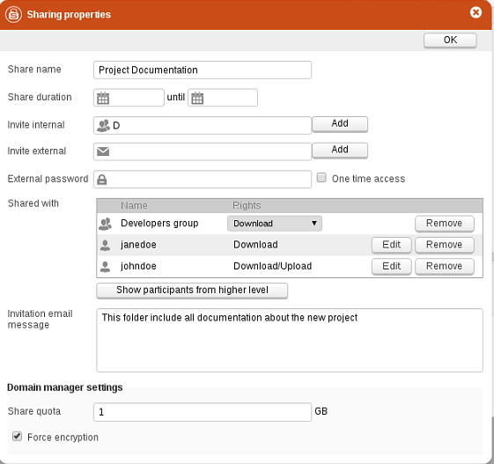
Figure 6: The domain manager access control utility
The client controls security from the user side and in the cloud. It is implemented on different platforms. The proposal supports the concept of the light-weighted client i.e. it does not do much encryption or other critical/heavy operations – all encryption is done on the server side and client just supports the key usage.
The unique feature is that every time the encrypted files are not downloaded again if the keys remain the same. The user can use his downloaded file after authentication with the password and email and it is kept securely (encrypted with unique AES key) in his storage device. The access to the AES key is controlled by the server, ABE encryption and key expiry period. The operation of regenerating the public keys and resending them to users are not time-consuming due to the implementation design. The results of testing the user key generation procedure for the 1000 user logins and 1000 key samples out of 20 parallel threads are show in Table 2.
Table 2: User key generation procedure results
User login | Average | Min | Max | KB/sec | Avg. Bytes
5 shares available | 982 | 225 | 1990 | 146.36 | 7459
10 shares available | 1140 | 340 | 4176 | 223.88 | 13218
25 shares available | 1267 | 887 | 2303 | 294.55 | 19466

These results show that the proposed Storgrid security infrastructure is light-weighted and designed to reduce the network load without compromising the level of user security. These properties perfectly match the security needs of the SMART architecture.

CONCLUSIONS
This paper proposes a security infrastructure solution for Cloud-based Big Data Analysis systems. Particularly, this proposal aims cloud-based systems that handle massive amounts of data in real time analysis coming from very diverse data sources, which is the motivation for the SMART architecture. The proposed infrastructure provides authentication and access control mechanisms appropriate to deal with the high demands of the applications intended to be support by SMART. This infrastructure is implemented and tests performed so far provide evidence that it imposes low overhead without compromising the security level being suitable for SMART application purposes.
Future works are planned to fully integrate the proposed security infrastructure in the SMART architecture. Additional load tests are to be performed in order to assess its scalability under a variety of system usage profiles, i.e. under different demands of the real time big data analysis and varying types of data sources.

REFERENCES
- Mell P. and Grance, T. The NIST Definition of Cloud Computing. Tech. Rep., Sep. 2011. [Online]. Available: http: //csrc.nist.gov/publications/nistpubs/800-145/SP800-145.pdf
- Stonebraker, M. et al. Intel "Big Data" Science and Technology Center Vision and Execution Plan. SIGMOD Rec., 42, 1 (May 2013), 44–49.
- Anjos, J. C. S. et al. BIGhybrid – A Toolkit for Simulating MapReduce in Hybrid Infrastructures. In Proceedings of the 2014 International Symposium on Computer Architecture and High Performance Computing Workshop (SBACPADW), Oct 2014, 132–137.
- Le, D.-H. et al. SALSA: A Framework for Dynamic Configuration of Cloud Services. In Proceedings of the 2014 IEEE 6th International Conference on Cloud Computing Technology and Science (CloudCom), Dec 2014, 146–153.
- Delamare, S. et al., SpeQuloS: a QoS service for BoT applications using best effort distributed computing infrastructures. In Proceedings of the 21th international symposium on High-Performance Parallel and Distributed Computing, ser. HPDC ’12. New York, NY, USA: ACM, 2012, 173–186.
- Alexandrov, A. et al. The Stratosphere platform for big data analytics. VLBD Journal, 23, 6 (2014), 939–964.
- Mashayekhy, L. et al. A PTAS Mechanism for Provisioning and Allocation of Heterogeneous Cloud Resources. IEEE Transactions on Parallel and Distributed Systems, 99, 1–14, 2014.
- Bethencourt, J., Sahai, A. & Waters, B., Ciphertext-policy attribute-based encryption. Proceedings of IEEE Symposium on Security and Privacy, pp. 321-334, 2007
- Goyal, V., Pandey, O., Sahai, A. & Waters B., Attribute-based encryption for fine-grained access control of encrypted data. Proceedings of the 13th ACM conference on Computer and communications security, pp. 89–98, 2007.
- Kamara, S. & Lauter, K., Cryptographic cloud storage. Proceedings of the 14th international conference on Financial cryptography and data security, pp. 136–149, 2010.
- Liu, Q., Tan, C.C., Wu, J. & Wang, G., Reliable re-encryption in unreliable clouds. Proceedings of the IEEE Global Telecommunications Conference, pp. 1–5, 2011.
- Sahai, A. & Waters, B., Fuzzy identity based encryption. Advances in Cryptology: EUROCRYPT, 3494, pp. 457–473, 2005.
- V. Hu, D. Ferraiolo, R. Kuhn, A. Schnitzer, K. Sandlin, R. Miller, and K. Scarfone, “Attribute Based Access Control Definition and Consideration,” NIST Special Publication 800-162, Gaithersburg, MD, USA, 2013.
- D. Yuefa, W. Bo, G. Yaqiang, Z. Quan and T. Chaojing, “Data Security Model for Cloud Computing,” In Proceedings of the 2009 International Workshop on Information Security and Application (Qingdao, China 2009), pp. 141-144, 2009.
- The Cloud Security Alliance research report. Top Ten Big Data Security and Privacy Challenges. Available at: [https://downloads.cloudsecurityalliance.org/initiatives/bdwg/Big_Data_Top_Ten_v1.pdf].
- Whitworth J., and Suthaharan S. Security Problems and Challenges in a Machine learning-based Hybrid Big Data Processing Network Systems. SIGMETRICS Perf. Eval. Rev., 41, 4 (March 2014 ), 82-85.
- Smith K.T. Big data security: the evolution of Hadoop’s security model. InfoQ.com articles, August 2013. Available at:[ http://www.infoq.com/articles/HadoopSecurityModel].
- Storgrid EFSS: secure enterprise filesharing software. Available at: http://www.storgrid.com.

